  - River Valleys Continuum of Care (MN-502)

Project Impact Statement

A. Summary
Application type |  | Project type
Target population
Target geography
Two sentence description of project

B. Guidance from people with lived experience of homelessness
Projects should include persons with lived experience of homelessness in the planning and implementation of the grant. For this project,
- Who was consulted in the development of this project? How?
- What guidance was received and applied to the project plan?
- How will participants or others with lived experience be involved after the project begins?

C. Leveraged resources & partnerships
Projects should request HUD CoC funds as part of project resources and bring in other critical resources to create a comprehensive housing and services program.
Type of resource | What will be provided | Who will provide it | Written commitment
Healthcare |  |  | - Attached  - Will be provided by ____/___/____
PHA or other rental assistance |  |  | - Attached  - Will be provided by ____/___/____
Education or employment services |  |  | - Attached  - Will be provided by ____/___/____
Other (describe) |  |  | - Attached  - Will be provided by ____/___/____

D. Expected results
Help us understand why this project is important to the homeless response system and how we will know if it is successful. What changes we should see for participants and for your community as a result of this project? Identify at least 3 results in each box on the following page. Results in the Community/System area must address at least 2 of the System Performance Measures shown below. Identify specific numbers whenever possible, e.g. Year 1: Employment training program created with Agency Z, Year 3: 30% of participants gain income from employment.
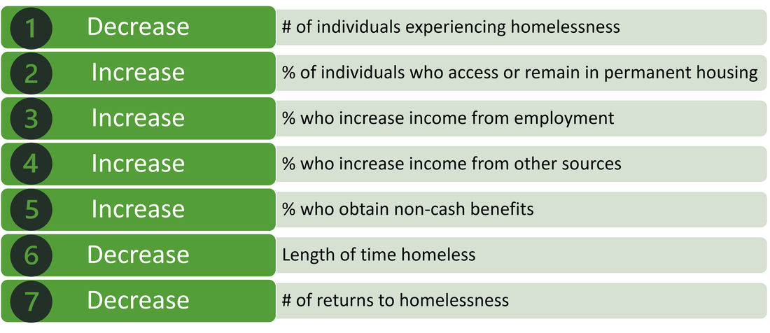
 | Expected Results after 1 year | Expected Results after 3 years
For participants in the program
For System/ Community

